EISLER Artix7 FPGA kit Broucher



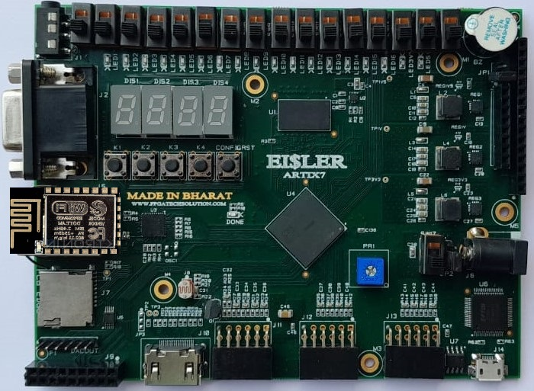

The EISLER-A7 board is a complete, ready-to-use digital circuit development platform based on the latest Artix7 Field Programmable Gate Array (FPGA) from Xilinx. With its high-capacity FPGA (Xilinx part number XC7A35T-1CSG324C ARTIX7), low overall cost, and collection of USB, VGA, HDMI and other ports, the EISLER-A7 can host designs ranging from introductory combinational circuits to complex sequential circuits like embedded processors and controllers.
www.fpgatechsolution.com
It includes enough switches, LEDs and other I/O devices to allow a large number designs to be completed without the need for any additional hardware, and enough uncommitted FPGA I/O pins to allow designs to be expanded using Pmods or other custom boards and circuits. An advantage of Artix7 over Spartan 6 is more logics resources and fully compatible with Vivado design suite. Xilinx offers free WebPACK™ versions of Vivado design suite, so designs can be implemented at no additional cost.
EISLER Artix7 FPGA kit Broucher
The EISLER-A7 board has on board USB JTAG which support Vivado & vitis. EISLER-A7 FPGA kit is ready to use Laboratory kit for ECE Curriculum. It can be useful for developing basic to advanced level digital circuits.

Technical Specification
- Xilinx XC7A35T-1CSG324C ARTIX7, 12,800 logic cells in 5000 slices
- 2Gb ddr3 memory
- 16 user switches
- 16 user LEDs
- 4 user pushbuttons
- 100MHz clock
- 4-digit 7-segment display
- Three Pmod ports (24GPIO), can be used for 12 diff channel xadc
- ESP-12E WiFi
- Buzzer
- RGB LED
- HDMI out
- 12Bit VGA output
- USB-UART
- Serial Flash 32Mbit
- LM35 temperature sensor connected to XADC pin
- LDR connected to XADC pin
- Preset connected to XADC pin
- 8Bit SPI DAC
- SD CARD
- Stereo 3.5mm Jack (Audio out)
- USB-JTAG port for FPGA programming and communication (support Vivado)
- 16BY2LCD (Add on)
- Rpi mipi csi camera 5MP (Add on)
- OV7670 VGA camera (Add on)
- Matrix keypad 4x4 (Add on)
- TFT display 160×128 (Add on)
- OLED display 128*32 (Add on)
- Relay driver board (Add on)
- Stepper/DC/Servo motor driver (Add on)
- Wooden Box Enclosure (Add on)
www.fpgatechsolution.com

EISLER Artix7 FPGA kit Broucher
Applications

- Product Prototype Development
- Development and testing of custom embedded processors
- Signal Processing
- Communication devices development
- Educational tool for Schools and Universities

Package includes

- Eisler-A7 FPGA board
- Micro usb cable
- 16BY2 LCD (Addon)
- Rpi 5MP camera (Addon)
- OV7670 camera (Addon)
- TFT DISPLAY 160×128 (Addon)
- Matrix keypad 4x4 (Addon)
- OLED (Addon)
- Motor driver (Addon)

Eisler Artix7 FPGA board can be available with following part number
XC7A50TCSG324-2
XC7A75TCSG324-2
XC7A100TCSG324-2

www.fpgatechsolution.com

